Go to http://www.onetonline.org
Under “Occupation Quick Search”, enter keyword(s) of occupation title and then either press “enter” or click the arrow immediately to the right.
For this example we want to find Aircraft Mechanics, so the keyword “Aircraft Mechanic” was entered.
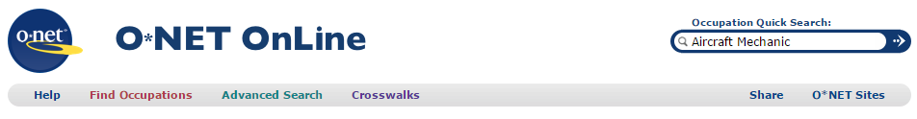
In the list of returns, find the link that most closely matches your interest.
For this example “Aircraft Mechanics and Service Technicians” is our best match; click the link.
We will use this title when we perform our search on the FREIDA website later.
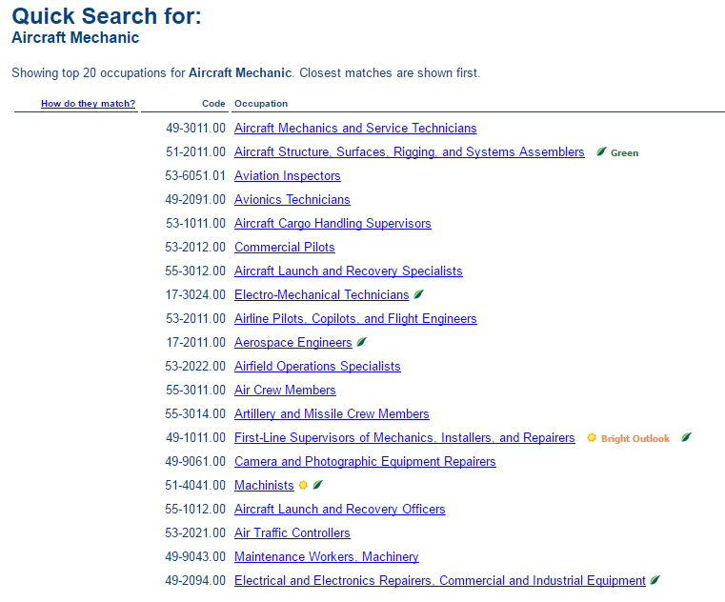

Under “Sources of Additional Information”, click on the occupational link (“Aircraft Mechanics and Service Technicians” for this example)
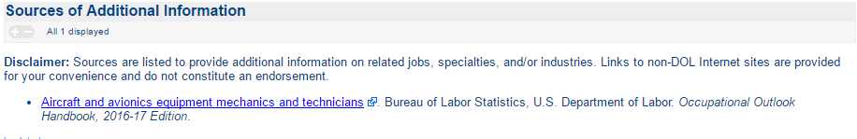
This will open a Bureau of Labor Statistics link summary page, providing National “Quick Facts” about the selected vocation. After reviewing the information, click on “How to Become One” to learn about the Education, Training, Licenses, Certifications, Registrations, Etc. requirements specific to that vocation.
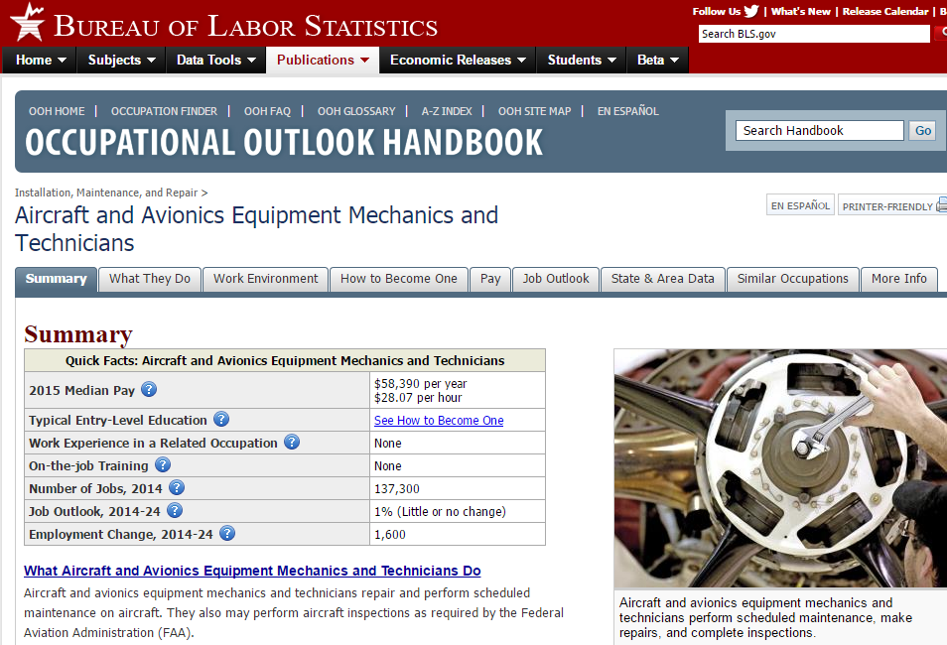

Below is an excerpt from the “How to Become One” for Aircraft and Avionics Equipment Mechanics and Technicians.
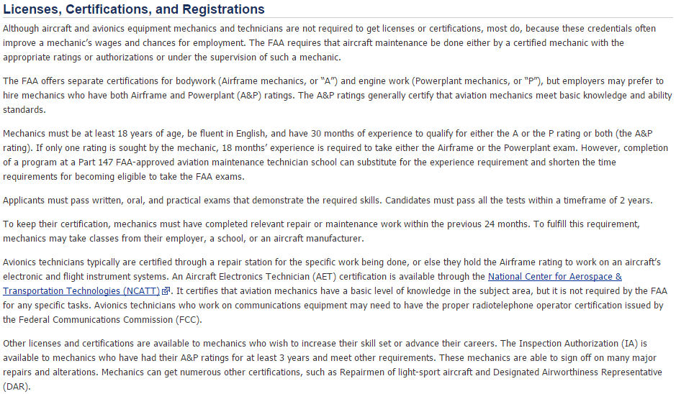

From the previous O*NET page, under the “Wages & Employment Trends” heading and to the right of “State wages” click on “Local Salary Info”
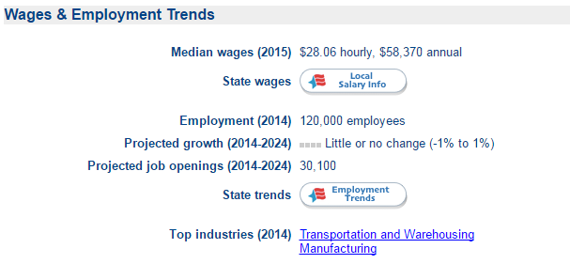
A Popup will appear, utilize the pull down menu to select “Florida” then click “Go”.
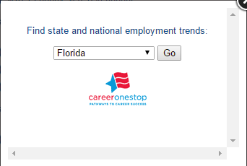
Click on “Open in new tab” at the bottom of the popup.
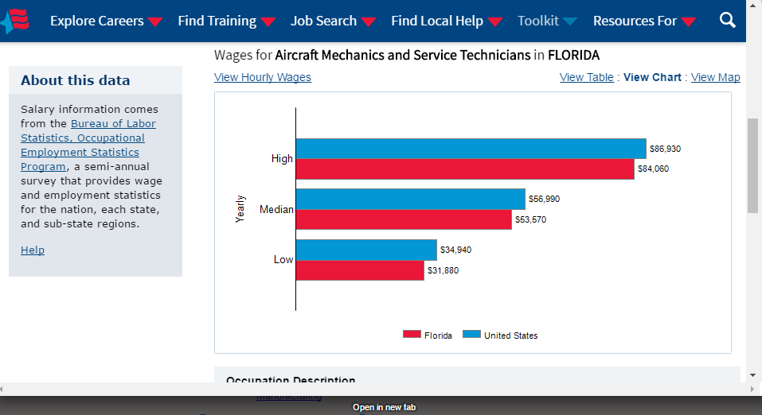
A Full sized web page will open showing wage data for the selected occupation for both the United States and the state of Florida.
You may enter the zip code in the “Location” field and click “Search”. If there is wage data available for that location it will be displayed, otherwise “No Data Available” will be displayed .
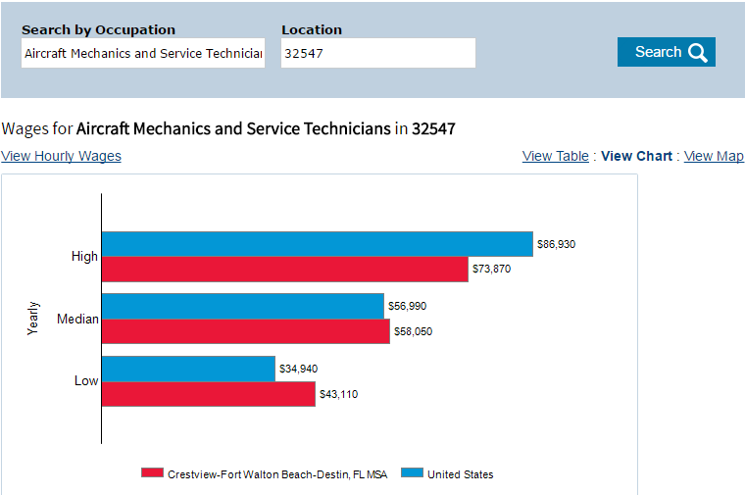
From the previous O*NET page, under the “Wages & Employment Trends” heading and to the right of “State trends” click on “Employment Trends”

A Popup will appear; utilize the pull down menu to select “Florida” then click “Go”.
This will return “State and National Trends” for the occupation selected.
Note: Do not trust percentages alone; look at the actual number of jobs. In the example below a +10% growth rate is projected for Florida, suggesting 410 more jobs will be added per year.
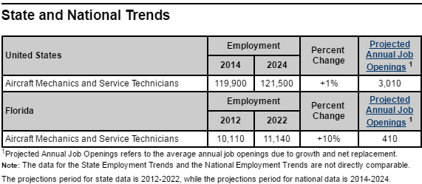

Go to http://freida.labormarketinfo.com/default.asp
Under “Labor Market Data” click on “Occupational Employment Statistics (OES) and Wage”
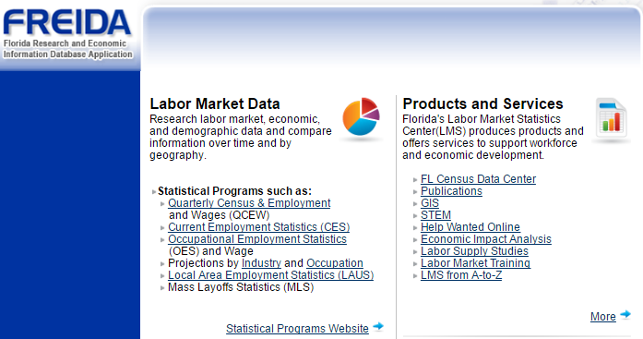
Under “Current Data Analysis” click on “Occupation Specific Data”
Then Click on “Employment and Wage Data”
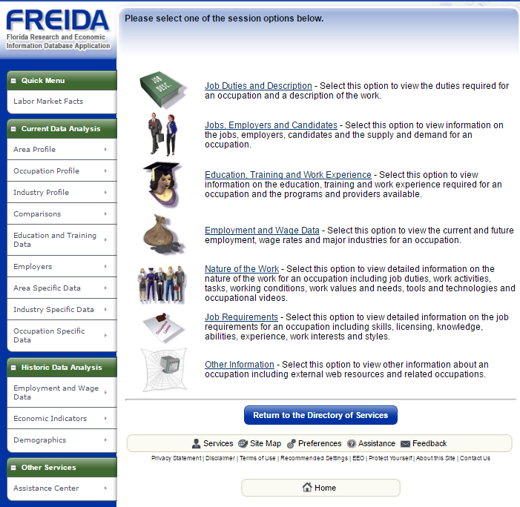
Next, click on “Wages”
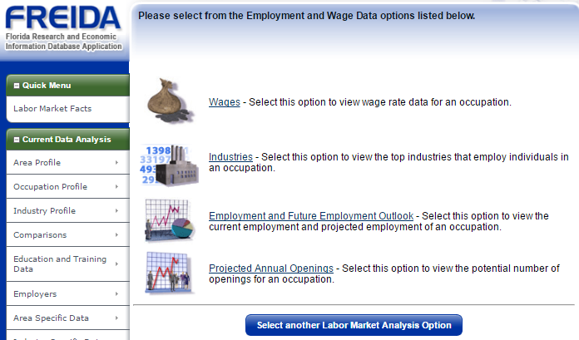
Next, under “Search for an occupation by keyword(s)” enter your keyword(s) then click on “Search”.
Note: Best practice is to use keyword(s) that matches the O*NET title for the job you are interested.
For this example, we are searching for “Aircraft Mechanics and Service Technicians” (O*NET Code 49-3011.00); “Aircraft Mechanic” was entered for the keyword search.
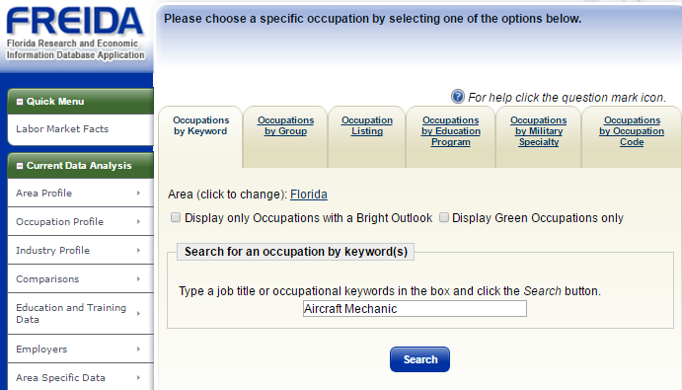

A list of returns will be presented, click on the link that you are interested in.
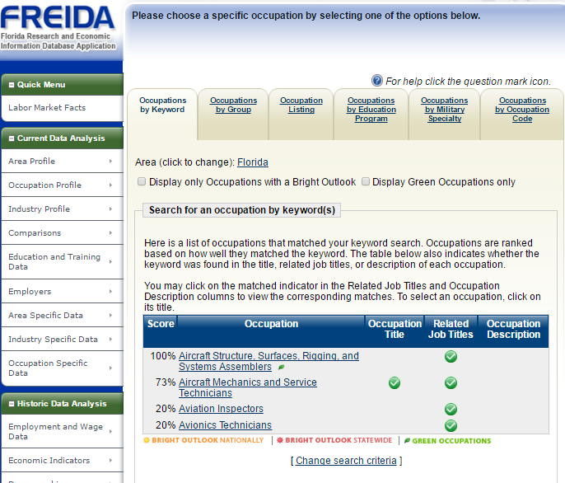
Under “Employment Wage Statistics” you will see the Entry/Mean/Experienced wage data for the state of Florida
Note: Read the text displayed below the “Show Display Options” – there may not be state specific information available for the specified vocation. If not, FREIDA will substitute the most closely matching category.
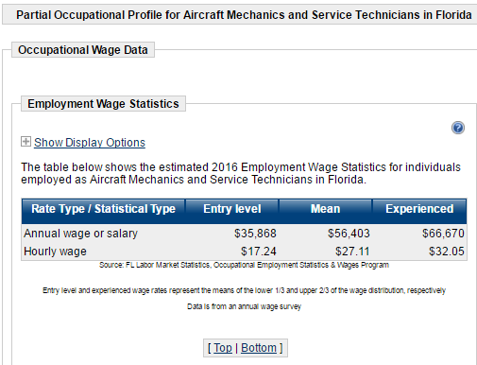

Under “Wage Rates Area Distribution” Click on the “+” to the left of “Show Display Options”
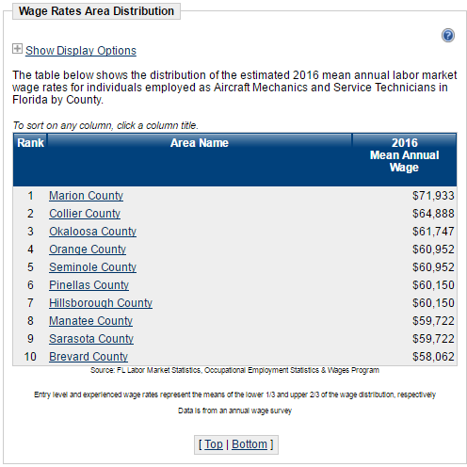

Under “Number of Records” use the pull down menu to select “All”
You can now see the Mean Annual Salary for all reported counties.
Click on the county of interest to display their Entry/Mean/Experienced wage data.
For this example, we selected “Okaloosa County”.
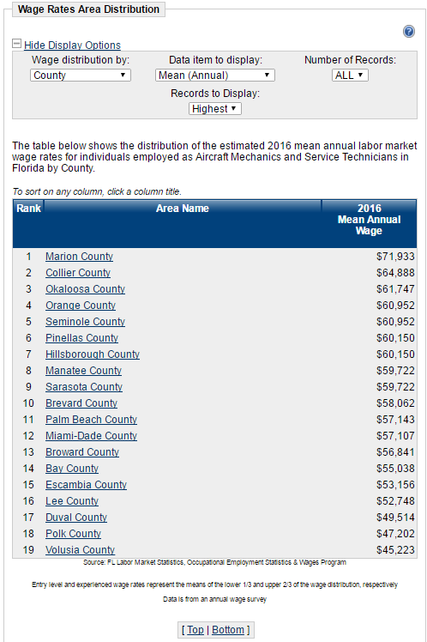

Under “Employment Wage Statistics” you will see the Entry/Mean/Experienced wage data for the county selected.
Note: Read the text displayed below the “Show Display Options” – there may not be county specific information available for the specified vocation. If not, FREIDA will substitute the most closely matching category.
